**SVKM’s NMIMS**

**Mukesh Patel School of Technology Management & Engineering**

**Computer Engineering Department**

**Program: BTech Integrated Sem III**

**Course: C Programming**

**2022-2023**

**Experiment No.05**

PART A

(PART A: TO BE REFFERED BY STUDENTS)

**A.1 Aim:** **To study** **Basic program control 1 in C program.**

1. Write a program to find the factorial of a number.
2. Write a program that displays the following patterns:

****

***

**

*

3.Write a Program to print pattern using for loop

1

12

123

1234

12345

4. Write a program to display first n elements of Fibonacci series.

5. Write a program to print

Hello Hello Hi

Hello Hello Hi

Hello Hello Hi

Hello Hello Hi

A.2 Prerequisite:

Basic program control 1 in C program “**for loop**”,

A.3 Outcome:

After successful completion of this experiment students will be able to

Develop and Execute C programs for loop constructs.

A.4 Theory:

## C Programming Loops

Loops cause program to execute the certain block of code repeatedly until test condition is false. Loops are used in performing repetitive task in programming. Consider these scenarios:

* You want to execute some code/s 100 times.
* You want to execute some code/s certain number of times depending upon input from user.

These types of task can be solved in programming using loops.

There are 3 types of loops in C programming:

1. for loop
2. [while loop](http://www.programiz.com/c-programming/c-do-while-loops)
3. [do...while loop](http://www.programiz.com/c-programming/c-do-while-loops)

## for Loop Syntax

for(initialization statement; test expression; update statement) {

code/s to be executed;

}

### How for loop works in C programming?

The initialization statement is executed only once at the beginning of the for loop. Then the test expression is checked by the program. If the test expression is false, for loop is terminated. But if test expression is true then the code/s inside body of for loop is executed and then update expression is updated. This process repeats until test expression is false.

This flowchart describes the working of for loop in C programming.

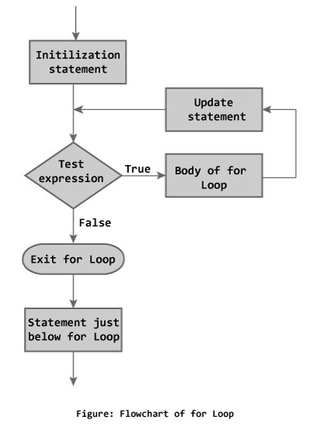

### for loop example

**Write a program to find the sum of first n natural numbers where n is entered by user. Note: 1,2,3... are called natural numbers.**

#include <stdio.h>

**int** main(){

**int** n, count, sum=0;

printf("Enter the value of n.\n");

scanf("%d",&n);

**for**(count=1;count<=n;++count) //for loop terminates if count>n

{

sum+=count; /* this statement is equivalent to sum=sum+count */

}

printf("Sum=%d",sum);

**return** 0;

}

**Output**

Enter the value of n.

19

Sum=190

In this program, the user is asked to enter the value of n. Suppose you entered 19 then,  count is initialized to 1 at first. Then, the test expression in the for loop,i.e.,  (count<= n) becomes true. So, the code in the body of for loop is executed which makes sum to 1. Then, the expression ++count is executed and again the test expression is checked, which becomes true. Again, the body of for loop is executed which makes sum to 3 and this process continues. When count is 20, the test condition becomes false and the for loop is terminated*.*

**PART B**

(PART B: TO BE COMPLETED BY STUDENTS)

**(Students must submit the soft copy as per following segments within two hours of the practical. The soft copy must be uploaded on the Blackboard or emailed to the concerned lab in charge faculties at the end of the practical in case the there is no Black board access available)**

|  |  |
| --- | --- |
| Roll No. | Name: |
| Program: | Division: |
| Semester: | Batch : |
| Date of Experiment: | Date of Submission: |
| Grade : |  |

B.1 Algorithm

1.

2.

3.

B.2 Flow Chart

1.

2.

3.

B.3 Program Code

1.

2.

3.

B.4 Input-Output

1.

2.

3.

B.5 Conclusion:

*(****Students must write the conclusion as per the attainment of individual outcome listed above and learning/observation noted in section B.3)***